The new ERN monitoring platform

**Information for ERN Members**

In 2024 all ERN members (full members and affiliated partners) will use the new platform to report on two indicators (New patients and use of Orpha codes). All the other indicators will be reported in the way agreed with each ERN in the past. To be able to use the new platform, each ERN member needs to request access.

These are the steps a member of an ERN must follow to request access to the new monitoring platform:

1. Designate a person to report – the reporter.  
   It can be the representative, the sub-representative or other person.
2. The reporter must use (create, if not yet done) an EU login account and associate a mobile phone. This process is common to all EU IT platforms and is not covered in these guidelines. Detailed instructions can be found [here](https://webgate.ec.europa.eu/cas/login).
3. Once the reporter has an EU login account, he or she must submit to the ERN a request to use the new monitoring platform. To do so, the reporter must use [this link](https://webgate.ec.europa.eu/saas). The process is like the one used to ask access to the CPMS and is explained in **Annex 1**. A video demo will be available soon.
4. The ERN local admin approves the request.

The approval has immediate effect. However, please note that in exceptional circumstances it may take longer. Once the approval is effective, the reporter can enter the monitoring platform using [this link](https://webgate.ec.europa.eu/sante-xmlgate/#!/forms/ern-indicators). And to enter the data in the platform, please refer to **Annex 2.**

Once in the platform:

1. The reporter chooses the ERN he or she is reporting to. In case the reporter is reporting to just one ERN, this choice is not needed as the ERN is automatically identified.
2. The reporter unblocks the form by ticking a disclaimer box.
3. The reporter fills in the two indicators:

* Number of new patients referred to the ERN member, with the diagnosis of a disease or condition falling within the scope of the ERN [number].
* Whether the ERN member uses Orpha codes to code/classify patient cases [Yes, No, Not Applicable].

1. The reporter can leave an optional comment.
2. The reporter ticks the confirmation box.
3. The reporter submits the form.
4. The reporter saves a pdf copy of the submission.

At any moment before submission, the reporter can save the form, log out, login at a later occasion and continue working on the form.

Annex 1: Member requesting access

1. Go to <https://webgate.ec.europa.eu/saas/> and select **SDCP-ERN-INDICATORS** from the list of applications.
2. Select **Request an access** (green button)

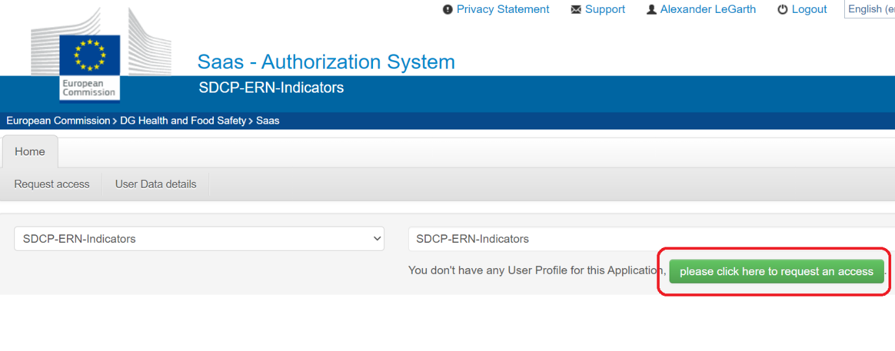

1. Leave application as SDCP-ERN-Indicators and press **Step 2**

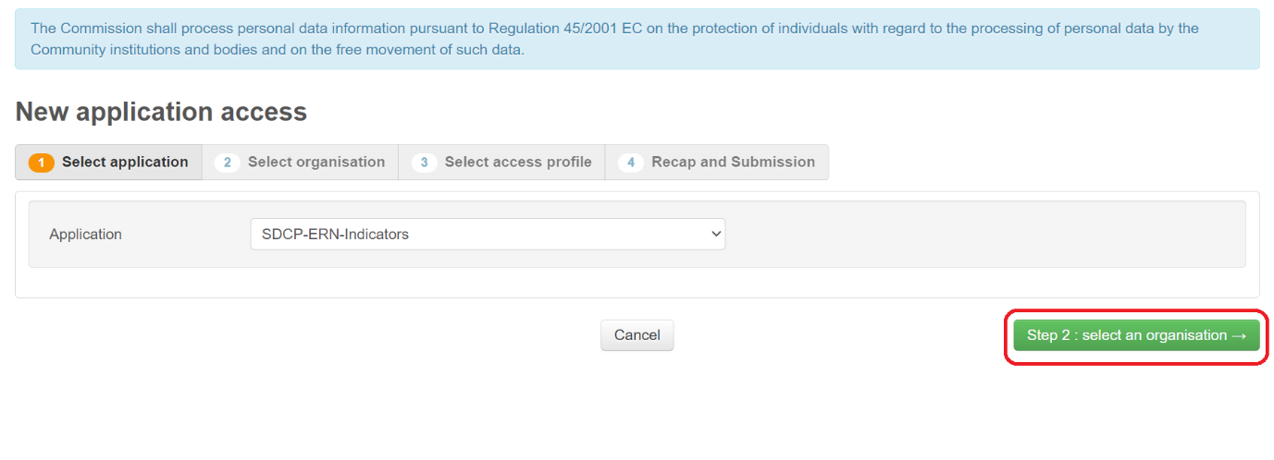

1. Select your network by pressing **Open**

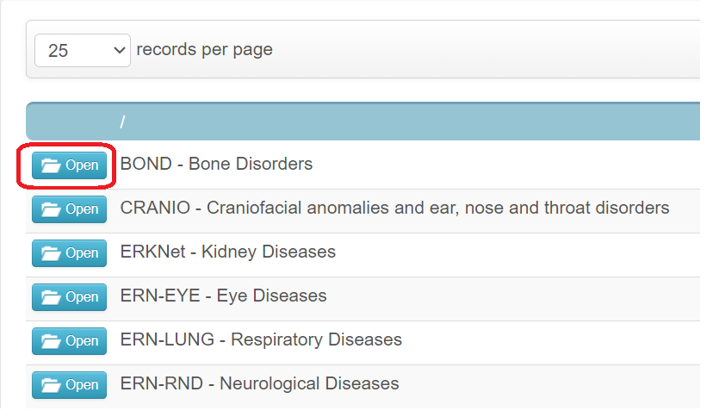

1. Select your country by pressing **Open**

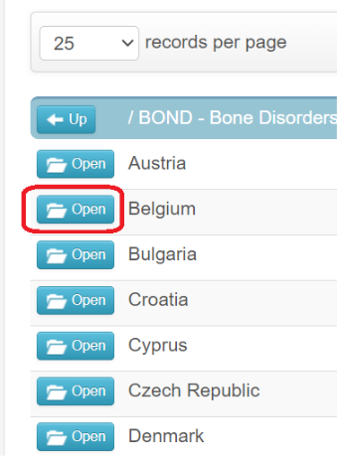

1. Select your HCP by clicking in the circle and then pressing **step 3**

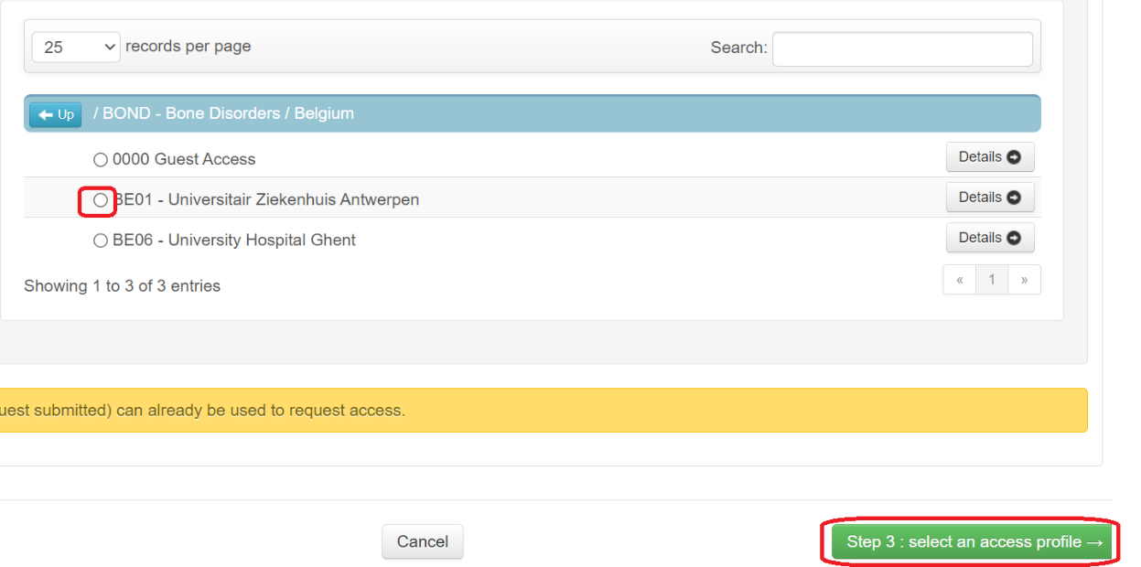

1. Select the role **ERN-Ind-User** by ticking the box and then press **Step 4**

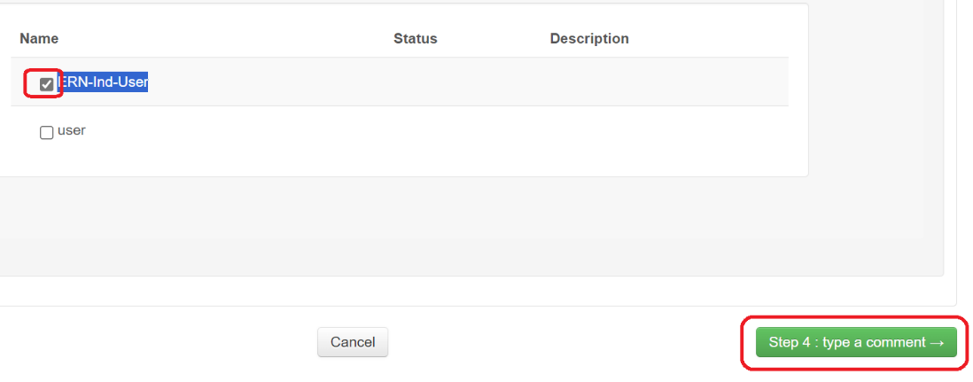

1. Press **submit access request**

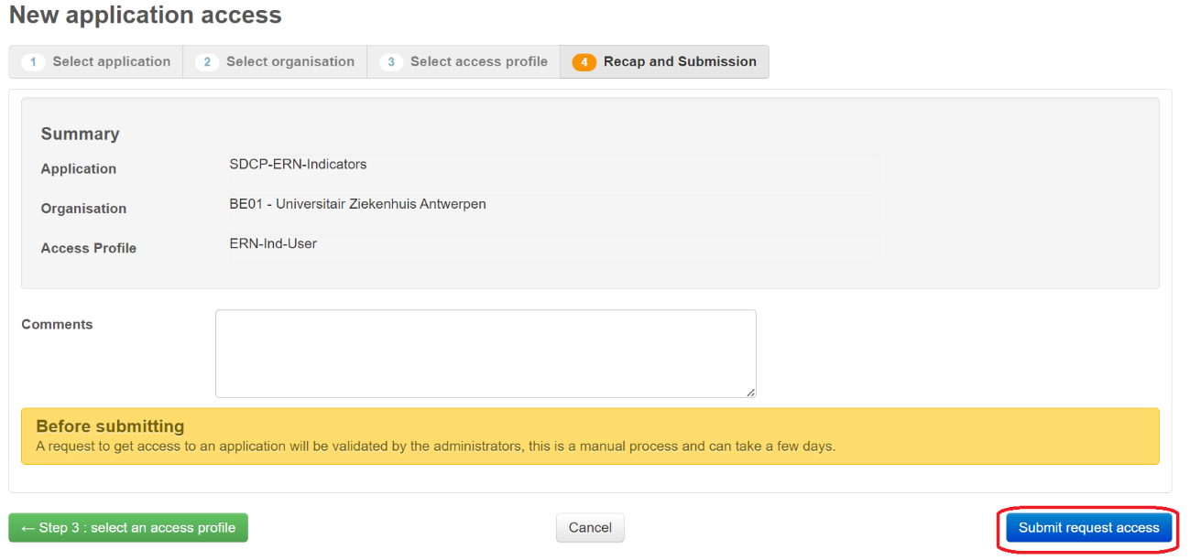

Annex 2: Enter the data in the platform

1. Go to <https://webgate.ec.europa.eu/sante-xmlgate/#!/forms/ern-indicators>

and click on: **“2023-ERN Members and Affiliated Partners”**

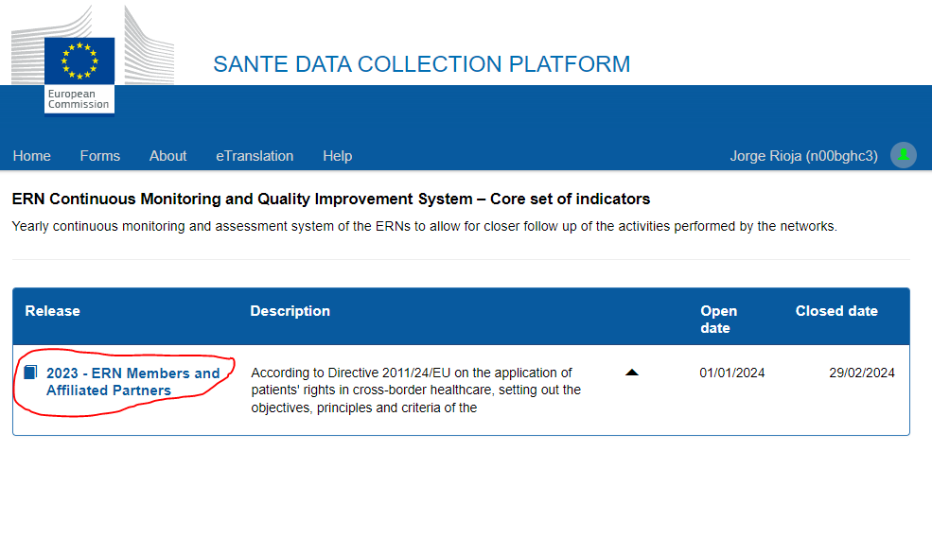

1. Select: “Create new dossier”

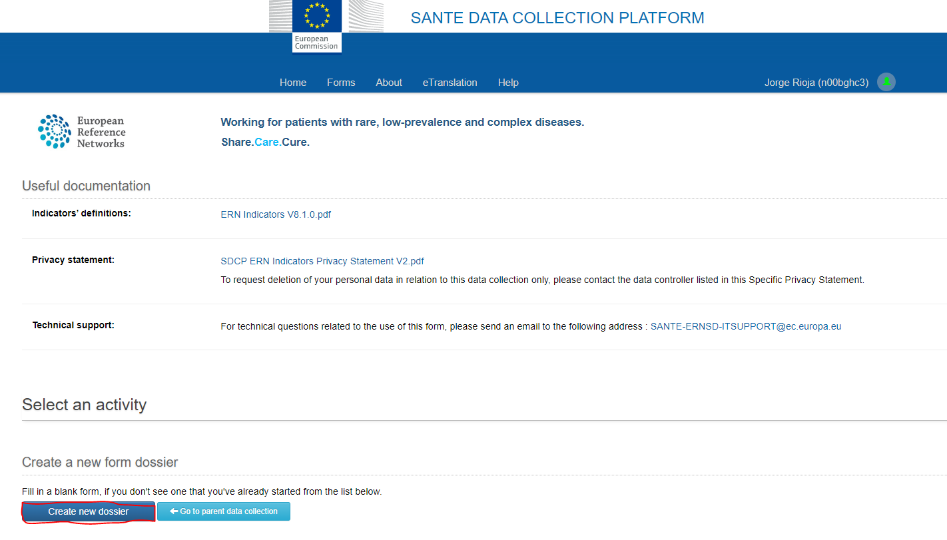

1. Check the box marked with the red check mark:

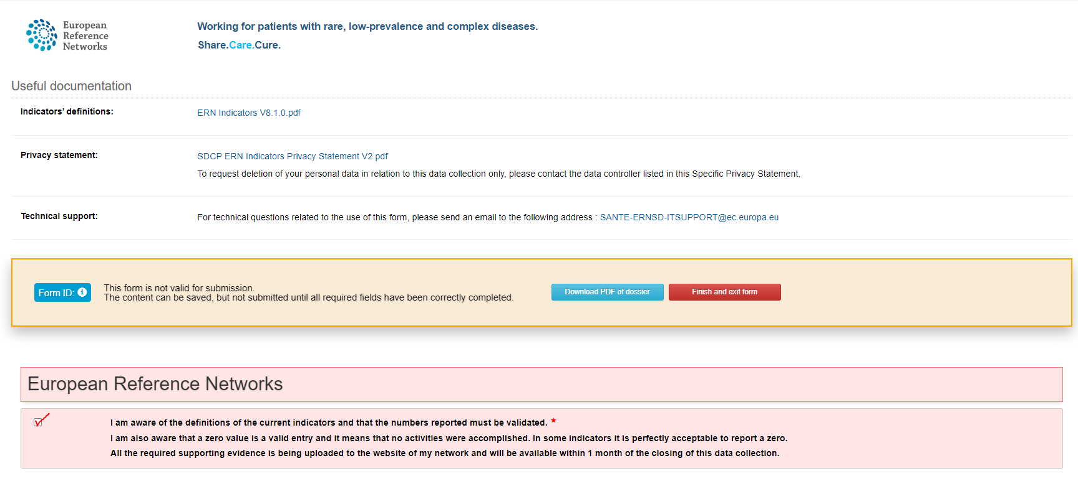

1. Fill in the two indicators marked with the data of your center and then check the box marked with the red check mark.

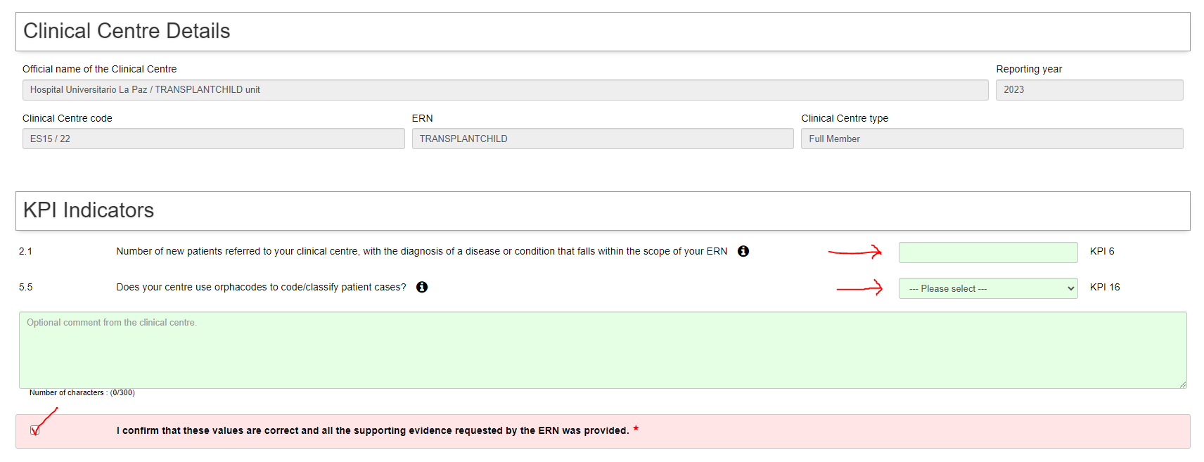

1. Finally:

1º Download and save the “PDF of the dossier”

2º Click on: “Submit and close form”

